Functional Specification Document

PROJECT: MVP 2 Farming Engagement Hub
EPIC: Farmer Segmentation
Functionality: Segmentation Simulation and Approval
User Story ID: PA-SEG-005
Functional Specification For: (X) Web Application ( ) Mobile Application
Portal: Back Office PA (Web)
Prototype: BAT - Agri 360 — Figma (segmentation flows)

Contents
- 1. Revision History
- 2. Sign-off
- 3. Process Specification
- 4. User Interface & User Experience
- 5. Policy & Regulatory Requirements
- 6. Technical Requirements
- 7. Positive & Negative Testing

1. Revision History
Date | Name | Change | Version
26/05/2026 | Matheus Kist | Initial document draft | 1.0

2. Sign-off
All screens described in this document are operated by the Backoffice PA User within the Back Office PA portal.
Date | Name | Role

3. Process Specification
- What? Run segmentation simulation; accept one result as official farmer segmentation for a target crop season — via Approval Workflow.
- Who? Backoffice PA User runs simulations; designated approvers accept as official via Approval Workflow.
- When? After KPI load and configuration publish.
- Where? Simulations list, create form, simulation detail (Web).
- How? Select configuration, target season, per-KPI scopes → run → review → submit approval → on approval, persist official segmentation.

3.2 Simulation lifecycle
Status | Meaning
Simulation | Completed run; not official.
Official | Accepted; drives official farmer segmentation for target season.

- Multiple simulations per target season allowed (Simulation status).
- At most one Official per target crop season.
- Accepting one simulation demotes any other Official for that season.
- Accept replaces all official segmentation rows for the season with simulation results (excluding new farmers).

3.3 Simulation inputs
- Segmentation configuration.
- Target crop season.
- Per-KPI scope: crop season list for each of Loyalty, Quality, Financial, ESG, Technologies, Yield, Scale.
- Optional value aggregation (Average / Last active crop data) where applicable.

4. User Interface & User Experience

4.1 SCREEN 01: Simulations — List and create
- Target crop season selector.
- Configuration dropdown.
- KPI scope section: multi-select seasons per KPI; aggregation radios per rules below.
- Prominent new-farmer rule callout.
- Run enabled when configuration and all seven KPI scopes are complete.
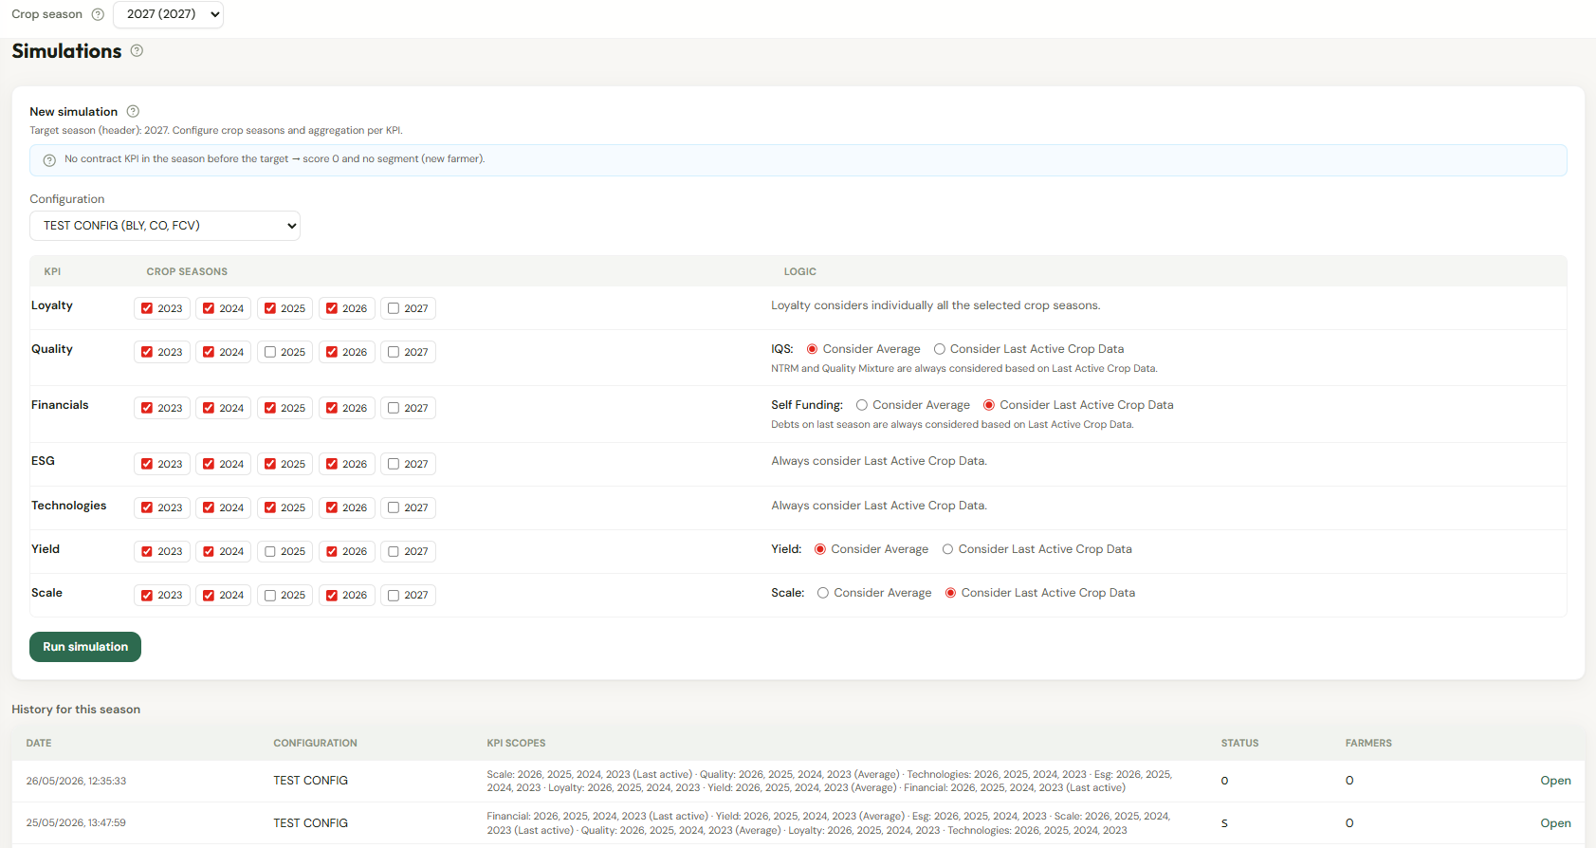
Figure 1 — Wireframe: simulations list and new simulation (KPI scopes).

4.2 SCREEN 02: Simulation detail
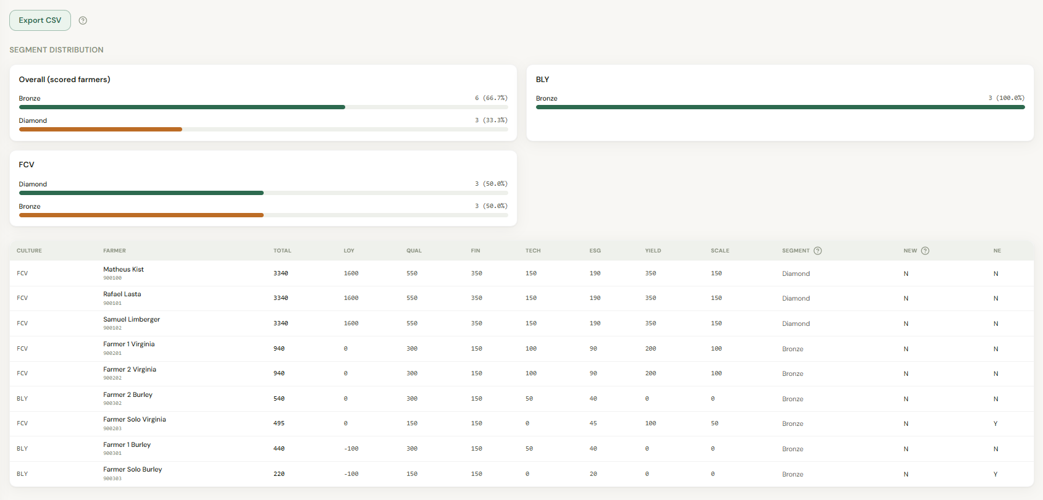
Figure 2 — Wireframe: simulation results and submit for approval.

- Read-only KPI scope summary.
- Segment distribution chart (excludes new farmers).
- Farmer results: code, name, culture type, component scores, total, segment, new-farmer flag.
- Export to spreadsheet.
- Submit for approval (replaces direct Accept in production).

4.3 Scoring rules — Overview

4.3.1 New farmer gate
Prior season = target crop season year minus one. If the farmer has no Farmer Contract KPI for that prior season and culture type: all scores = 0, no segment, excluded from distribution chart. This gate uses target season only, not per-KPI scopes.

4.3.2 Culture type selection
Use the culture type with the largest total Scale summed across Scale-scope seasons.

4.3.3 Aggregation by KPI
KPI | Aggregation | Notes
Loyalty | N/A | Multi-season rules on scope seasons.
Quality | Average or Last active | IQS uses selection; NTRM and mixture always last active in scope.
Financial | Last active or Average | Self-funding uses selection; have debt always last active.
ESG | N/A | Latest active season in ESG scope.
Technologies | N/A | Latest active season in Technologies scope.
Yield | Average or Last active | Range match on aggregated yield.
Scale | Last active or Average | Range match on aggregated scale (ha).

Average = mean over scope seasons where farmer has data. Last active = value from highest season year in scope with data.

4.3.4 Component rules (summary)
- Loyalty: planting count, delivery window on last D seasons, consolidated delivered % for historical bands; highest planting rule wins.
- Quality: IQS range match + NTRM/mixture add-ons.
- Financial: self-funding range + debt add-on.
- Technology: sum configured scores for adopted technologies in latest scope season.
- ESG: reforestation and native forest points capped + irregularity scores.
- Yield / Scale: range match on aggregated values.

4.3.5 Segment assignment
- Total score = sum of seven components.
- Segments with range min evaluated highest threshold first.
- Respect only-exclusive-farmer flag.
- Catch-all segments (no range min) after thresholds.
- New farmers never receive a segment.

4.4 Approval Workflow
New Approval Configuration (example code: SEG_SIMULATION_ACCEPT_OFFICIAL):
- Trigger: user submits Accept as official on simulation detail (Simulation status).
- Payload: simulation reference, target season, configuration name, farmer counts, segment distribution summary.
- On approve: set simulation to Official, demote other officials, replace official farmer segmentation for season.
- On reject: simulation remains Simulation; notify requester.
- Segregation of duties: creator and KPI editors must not be sole approver.

5. Policy & Regulatory Requirements
Official segmentation affects commercial terms — dual control required. Audit simulation id, scopes, configuration, approvers, timestamps.

6. Technical Requirements
- Reads Farmer Contract KPI, Technologies KPI, Irregularities KPI, and Segmentation Configuration.
- Writes official farmer segmentation on approval.
- Integrates with Approval Workflow engine.

7. Positive & Negative Testing
ID | Scenario | Expected result
T-01 | Incomplete KPI scopes | Run blocked.
T-02 | New farmer | Score 0, no segment, excluded from chart.
T-03 | Approve accept | Official status; segmentation replaced for season.
T-04 | Reject approval | No segmentation change.
T-05 | Loyalty consolidated % | Uses kg sums not average of %.

